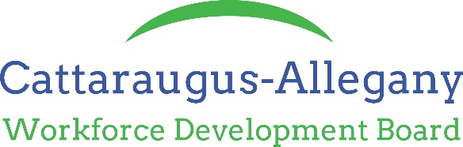

TO: All One Stop Center Staff
SUBJECT: Adult and Dislocated Worker Follow-Up Policy
ISSUANCE DATE: November 29, 2017
EFFECTIVE DATE: November 29, 2017
EXPIRATION DATE: None
_____________________________________________________________________________________

PURPOSE
This policy is to establish guidelines and criteria to be used in Adult and Dislocated Worker Follow-Up services for participants of the Workforce Innovation & Opportunity Act (WIOA) Programs.

POLICY STATEMENT
WIOA requires that follow-up services must be made available to Adult and Dislocated Workers for a minimum of 12 months following exit from the applicable program. The goal of follow-up services is to ensure job retention, wage gains and career progress for customers who have been placed in unsubsidized employment, received training or supportive services. Follow-up services could include, but are not limited to: additional career planning; counseling regarding the workplace; contact with the participant’s employer, including assistance with work-related problems that may arise; peer support groups; information about additional education opportunities; and referral to supportive services available in the community.

Not all of the Adults and Dislocated Workers who are registered and will need, or want, follow-up services. The appropriate scope and intensity of follow-up services must be based on the needs of the individual participant. In order to identify and meet these participant’s needs, Cattaraugus-Allegany Workforce Development Board (CAWDB) is requiring contact with participants at least once during each quarter after exit. If the participant requires additional services during any contact, the WIOA Service Provider is responsible for providing whatever services are allowable and suitable of the participant.

A follow-up log should be maintained in the file to document all contacts and efforts made on behalf of the participant during the 12-month follow-up period. Follow-up logs should verify the complete status of the participant, including place of employment, wage, hours per week, and information about any lapses of employment. The participant should also be asked if additional services are needed. Follow-up screens in OSOS must be updated quarterly to document that required follow-up has occurred.

PERFORMANCE ACCOUNTABILITY/APPROVED DOCUMENTATION FOR EMPLOYMENT VERIFICATION
In order to ensure the accuracy of participant employment status at the time of closure and during the applicable performance time periods, the CAWDB is requiring that one of the following sources be used to verify employment:
• An employer written affidavit/signed employment verification.
• Documentation of telephone conversation with employer or customer indicating that participant was employed during the period(s) required by the applicable measure. Telephone contact must document the name and title of the employer representative who verified the information.
• Copy of paycheck stub covering the period required by the applicable measure.
• For those self-employed: self-attestation covering the period required by the applicable measure.

Employment verifications should be obtained during each of the four quarters following program exit. While unemployment insurance wage records are the primary source of information in the calculation of performance rates, this supplemental data will be acceptable for calculating performance rates when wage data files are unavailable (with the exception of the average earnings measure).

CREDENTIALING
Credentials must be verified by a copy of the diploma, certificate, license, or training provider records. This documentation should be maintained in the follow up file. Credential information must also be entered into OSOS.

