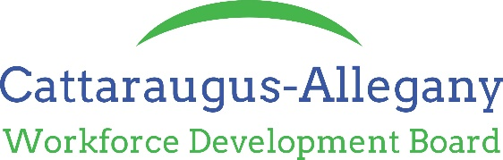

Operations Oversight Committee
Monday January 23rd –10:00 am
WDB Office Olean, NY
Not Approved
Board Members Present:  Brian George - Cutco  Kathleen Martel- JCC Olean  Lesley Christman – ACCORD by phone  Ed Giardini, Jr. - Laborers’ Union  Jessica Golley—Hi-Y Farms  Board Members Absent:  Frank McAndrew-NYSDOL  Meme Yanetsko - Greater Olean Chamber | Staff In Attendance:  Jason Miller – Executive Director  Tiffany Mager – Fiscal and Program Monitor  Others In Attendance:  Reita Lynch –Allegany E&T  Nikki Blough-Allegany E&T  Larry Knight – Cattaraugus One Stop
Brian called the meeting to order at 10:00 am.

Review Demand Occupation List
Reita had made a suggestion to add EMT to the Demand Occupation list. The committee discussed this. It was tabled for now as we need to do more research. Reita is unsure that the agency that provides the training in Allegany County is accredited to be on the Eligible Training Provider list. Ed suggested contacting the City of Olean Fire Department and the Allegany Fire Department to see who does their training of EMTs. Jason and Reita are going to do some more research.

Discussion of raising ITA rates
The committee started to discuss increasing the amounts available for ITAs and realized after some conversation that the ITA policy needs to be reviewed as it has been several years since the parameters for training were reviewed. We are setting up an Ad-Hoc committee to review the ITA amounts.

Discuss funding Bachelor’s Degrees in ITA
Jason brought up the idea of starting to fund Bachelor Degrees as ITAs. We currently don’t fund anything above an Associate’s Degree. St. Bonaventure’s Bachelors of Nursing program has inquired if we might be able to help their students with funding. The committee decided we need more information on the employment situation of the nurses in the class. If they are employed while taking the program then they would not fit under the Self Sufficiency guideline. It could be that a nurse is part time or currently unemployed then we might be able to help them. Jason is going to reach out to St. Bonaventure and find out more information.

NYSDOL Draft TA 23-a Adult Priority of Service
Jason explained the USDOL is putting more emphasis on this to NYSDOL. We currently have an Adult Priority of Service policy but with this TA NYSDOL is adding three other priorities to look for. Once this TA is officially released we will need to revise our policy and have the committee review it and recommend it to the Board for approval.

Meeting adjourned @ 10:38 pm

Next Meeting
To be determined

